

Start Here



**Change to developer mode**

When you change from production to developer mode, you should clear generated classes and Object Manager entities like proxies to prevent unexpected errors. After doing so, you can change modes. Use the following steps:

1. If you’re changing from production mode to developer mode, delete the contents of the var/generation and var/di directories:

sudo rm -rf /opt/bitnami/apps/magento/htdocs/var/di/*

sudo rm -rf /opt/bitnami/apps/magento/htdocs/var/generation/*

1. Set the mode:

sudo /opt/bitnami/apps/magento/htdocs/bin/magento deploy:mode:set developer

The following message displays:

Enabled developer mode.

**GET PUB/PRIV keys to access the sample data**

Get Keys from Magento Market Place

<http://devdocs.magento.com/guides/v2.0/install-gde/prereq/connect-auth.html>

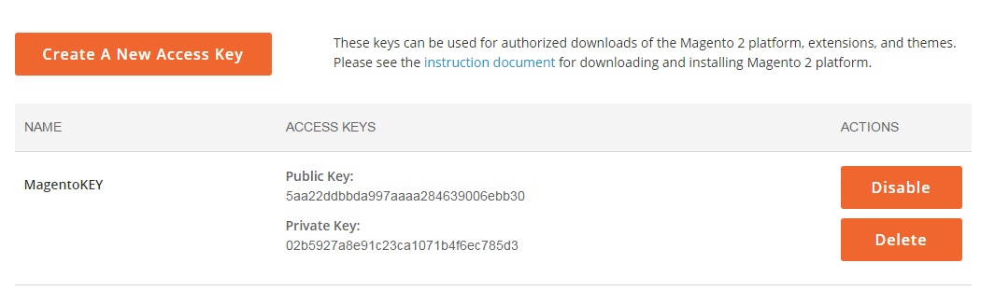

PUBLIC KEY IS YOUR USER NAME

PRIVATE KEY IS YOUR PASSWORD

**Install the Sample data using Composer**

<http://devdocs.magento.com/guides/v2.1/install-gde/install/sample-data-after-composer.html>

To install sample data using the command line, enter the following command as the Magento file system owner:

sudo php /opt/bitnami/apps/magento/htdocs/bin/magento sampledata:deploy

You are required to [authenticate](http://devdocs.magento.com/guides/v2.1/install-gde/prereq/connect-auth.html) to complete the action.

After you download the sample data packages, log in to your Magento server and enter the following command:

sudo php /opt/bitnami/apps/magento/htdocs/bin/magento setup:upgrade

**Increase Memory Limit**

Apparently there is a problem with the cache. In the meantime, please use this workaround:

These are the steps I followed in order to install an extension:

* I increased the Memory Limit in /opt/bitnami/apps/magento/conf/php-fpm/php-settings.conf editing the line:

sudo vi /opt/bitnami/apps/magento/conf/php-fpm/php-settings.conf

Press ‘I’ to insert

php_value[memory_limit]=256M

* with the value:

php_value[memory_limit]=768M

Esc :wq

sudo /opt/bitnami/apps/magento/bnconfig --regenerateKeys 1